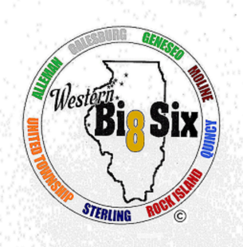
WESTERN BIG 6 CONFERENCE

2019 All Conference Boys Cross Country

First Team
Trey Heinz United Township Junior
John Hutton Moline Junior
Jackson McClellan Moline Junior
Roberto Munoz United Township Senior
William Plumley Geneseo Junior
Fiker Rosen Quincy Sophomore
Ben Vasquez Galesburg Junior
Logan Veloz United Township Sophomore
Tim Wolf Moline Senior
James Wright United Township Senior

Second Team
Sam Brown Sterling Junior
Javon Bruce Sterling Junior
Donovan Garro Rock Island Junior
Devin Hermsmeier Quincy Junior
Sam Janssen Sterling Senior
Justin Johnson Geneseo Sophomore
Lucas Nicke Geneseo Junior
Colby Rapps Geneseo Senior
Tony Vandewalle Rock Island Senior
Logan Wisocki United Township Senior

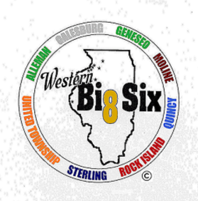
WESTERN BIG 6 CONFERENCE

2019 All Conference Girls Cross Country

First Team
Briana Admire Galesburg Freshman
Lauren Belvel Genese o Senior
Lylia Gomez Moline Junior
Lacey Laxton Geneseo Sophomore
Emily Lopez Moline Senior
Alexandria Meyers Quincy Freshman
Kylie Nicklaus Sterling Freshman
Lilian Peavey Sterling Sophomore
Brinley Rodgers United Township Senior
Anna Schuering Quincy Sophomore

Second Team
Madilyn Barnhart Sterling Senior
Andrea Cervantes Sterling Senior
Emma Hawkinson Galesburg Senior
Madison Lodico Moline Junior
Avery Magerkurth Geneseo Junior
Mika Martinez Sterling Junior
Maddie Miller United Township Sophomore
Grace Moore Alleman Senior
Eryn Robertson Moline Freshman
Analya Sedano United Township Junior

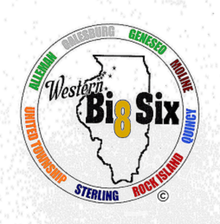
WESTERN BIG 6

2019 ALL CONFERENCE FOOTBALL

FIRST TEAM OFFENSE
Cooper Willman Senior Quarterback Sterling
Nate Sheets Senior Running back Alleman
Kaeden Dreifurst Junior Running back Moline
Aboubacar Barry Senior Running back Moline
Davion Wilson Senior Running back Rock Island
JaShawn Howard Junior Running back Sterling
Rudy Glancey Junior Lineman Alleman
Rob Stohl Senior Lineman Geneseo Patrick Pray Senior Lineman Moline
Nate Beyer Senior Lineman Sterling Ryan Heffelfinger Junior Lineman Sterling

FIRST TEAM DEFENSE
Jack Patting Junior Linebacker Alleman Jake Mattecheck Junior Linebacker Alleman
David Vaynerman Senior Linebacker Galesburg
Zion Rodriguez Senior Linebacker/Safety Moline
Nate Wilson Senior Linebacker Quincy
Nick Simester Junior Linebacker Sterling
Noel Aponte Junior Corner Back Sterling
Dominic DeBoef Junior Lineman Geneseo
J C Lackey Senior Lineman Quincy
Aidan Munoz Ripley Senior Lineman Sterling
Trevon Jordan Junior Lineman Sterling

FIRST TEAM SPECIAL TEAMS
(Punters, Kickers, Return Specialists, Long Snappers, etc.)
Jakye Hill Senior Returner Rock Island
Perry Slater Senior Returner Rock Island

FOOTBALL SECOND TEAM OFFENSE
Lucas Reis Senior Quarterback Quincy
Alexandre Egipciaco Sophomore Receiver Galesburg
Scott Sprick Senior Receiver Quincy
Drake Tournear Senior Receiver Quincy
Adante Crider Senior Running back Quincy
Jakye Hill` Senior Receiver Rock Island Blayze Purchase Senior Lineman Galesburg Collin Meyer Senior Lineman Moline
Dion Washington Senior Lineman Quincy
Har Ju Ree Junior Lineman Rock Island Simon Wilson Junior Lineman United Township

SECOND TEAM DEFENSE
LINEBACKERS & BACKS
Killian Ahern Senior Cornerback Alleman
Jonathan Maxwell Sophomore Linebacker Geneseo
Immanuel Bailey Senior Linebacker Moline
Grant James Senior Linebacker Quincy
Kenyhon Yancey Senior Cornerback Rock Island
Perry Slater Junior Safety Rock Island
Isaiah Yarbrough Senior Cornerback Sterling
Caleb Sharer Junior Lineman Alleman
Rudy Glancey Junior Lineman Alleman
Jaiden Vancoille Senior Lineman Rock Island
Jr. Farnham Sophomore Lineman Sterling

SECOND TEAM SPECIAL TEAMS
Sean O’Hern Senior Kicker Alleman
Lucas Reis Senior Punter Quincy
Michael Hanrahan Junior Returner Sterling

HONORABLE MENTION OFFENSE
Daslah Geadeyan Junior Quarterback United Township
Killian Ahern Senior Receiver Alleman
Nate Johnson Senior Receiver Moline
Perry Slater Junior Receiver Rock Island
Luke Heffelfinger Senior Receiver Sterling
Trevell Carpenter Junior Receiver United Township
Cole Gradert Senior Lineman Geneseo
Ben Duenas Senior Lineman Moline
Nate St. Dennis Senior Lineman Moline
Pharoah Gray Junior Lineman Rock Island
Adan Ramirez Senior Lineman Sterling
Royce Arnold Senior Lineman United Township

HONORABLE MENTION DEFENSE
Zach Carpita Junior Free Safety Alleman
Hunter DeVena Sophomore Linebacker Galesburg
Nikolas Deligiannis Senior Safety Galesburg
Kaden Davison Sophomore Linebacker Geneseo
Nathan Beneke Junior Defensive back Geneseo Treyvon Lee Junior Cornerback Moline
Drae Humphrey Junior Linebacker Quincy
Victor Guzman Senior Safety Rock Island
M J Stern Senior Linebacker Rock Island
Jayden Upton Senior Linebacker Rock Island
Connor Shipman Sophomore Lineman Geneseo
Donovan Rogers Senior Lineman Rock Island

SPECIAL TEAMS HONORABLE MENTION
Jackson Marx Junior Long Snapper Alleman Caroline Hazen Sophomore Kicker Moline
Trevell Carpenter Junior Returner United Township

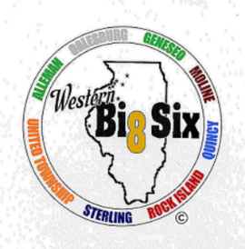

Boys Golf All Conference 2019

First Team
Preston Armstrong Quincy Senior
Danny Ford Geneseo Senior
Luke Lofgren Alleman Junior
Aaron Rogers Moline Sophomore
Jason Runbom Galesburg Freshman
Seth Winchell Geneseo Senior

Second Team
Cameron Bergman Quincy Sophomore
Drew Coleman Alleman Senior
Ben Frieden Moline Junior
Cole Nicholas Quincy Sophomore
Dylan Schueneman Moline Senior
A..J. Shoemaker Alleman Senior
Colton Sigel Rock Island Junior
Brady Walker Quincy Sophomore
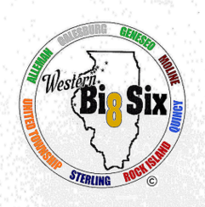
Girls Golf All Conference 2019

First Team
Paige Cain Quincy Sophomore
Laci Novosel Quincy Sophomore
Saya Geisendorfer Quincy Freshman
Megan Tanghe Alleman Senior
Jesse Pennington Rock Island Senior
Elizabeth Roadhouse Geneseo Senior
Avery Scott Quincy Senior

Second Team
Eryn Murray Geneseo Senior
Kacey Knary Moline Sophomore
Paige Laingen Geneseo Junior
Miranda Roemer Geneseo Junior
Averi Heintzelman Sterling Senior
Maddie Pick Sterling Sophomore
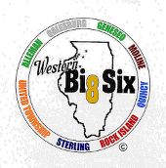

2019 BOYS SOCCER ALL CONFERENCE TEAM

FIRST TEAM
Jordan Seely Geneseo Midfield Senior
Blake Bastian Moline Forward Junior
Isaac Ruiz Moline Midfield Senior
Andrew VanderMaiden Quincy Forward Junior
Jack Bartley Quincy Midfield Senior
Isaac Almanza Rock Island Midfield Senior
Ceu Bik Lian Rock Island Midfield Senior
Jordan Rice Rock Island Forward Junior
Adrian Herrera Sterling Forward Senior
Tanner Viren United Twp. Defender Senior
Zach Bauer Geneseo Goalkeeper Senior

SECOND TEAM
Austin Fitch Alleman Forward Junior Joel Bizau Galesburg Defender Junior
Isaiah Mowen Galesburg Forward Senior
Ethan Holke Geneseo Defender Junior
Michael Galvin Moline Defender Junior
Jarod Raber Moline Midfield Senior
Blake Peter Quincy Fullback Senior
Peter Kimba Rock Island Defender Senior
Chan Nawl United Township Forward Junior
Ben Downey United Township Defender Senior
Frank Heck Quincy Goalkeeper Junior

HONORABLE MENTION
Jaime Diaz Alleman Midfield Sophomore
Aiden Breslin Galesburg Forward Junior
Ryan Morgan Geneseo Midfield Senior
Hunter Holke Geneseo Defender Sophomore
Nate Holke Geneseo Defender Junior
Nick Kelley Quincy Fullback Senior
Bromley Brown Quincy Forward Senior
Ben Terwelp Quincy Fullback Senior
Osvaldo Perez Rock Island Defender Senior
Isaiah Kerr Rock Island Forward Junior
Lucas Sotelo Sterling Midfield Senior
Marcos Rojas United Township Midfield Junior
Sergio Garcia Sterling Goalkeeper Sophomore

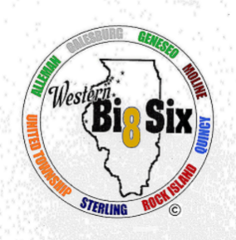
2019-2020 All Conference Girls Swimming

First Team All Conference
Taylor Puglisi Senior Moline
Hailey Glasnovich Senior Galesburg
Sophie Lotz Junior Galesburg
Kylie Tapper Freshman Galesburg
Abby Cermak Senior Galesburg
Sophie Greko Sophomore Moline
Gabbo :Lopez Senior Moline
Lauren Moeller Senior Sterling
Olivia White Junior Moline
Ciara Van Note Sophomore Moline
Olivia Sholl Sophomore Rock Island

Second Team All Conference
Molly Pettit Sophomore Galesburg
Hanna Gault Sophomore Moline
Mimi Trenary Junior Moline
CC Cervantes Junior Moline
Claire Tarpey Freshman Moline
Megan Christiansen Senior Sterling
Aviva Brenner Senior Sterling
Rebecca Riley Sophomore Sterling

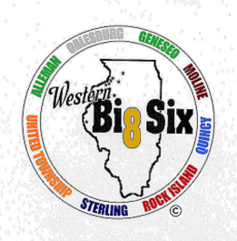

WESTERN BIG 6
Girls Tennis All Conference 2019

First Team
Otone Odaljima Quincy Junior
Monika Birski Moline Junior
Lauren Myers Moline Junior
Sarah Gustafson Moline Sophomore
Lucy Rector Alleman Junior
Kate Rector Alleman Freshman

Second Team
Olivia Clayton Quincy Senior
Reese Williams United Township Sophomore
Abby Aitken Sterling Senior
Saryn Seeley Sterling Senior
Mary Thomas Geneseo Senior
Emma Dunker Geneseo Junior

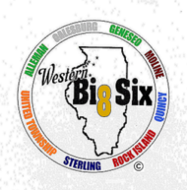
WESTERN BIG 6 VOLLEYBALL
2019 ALL CONFERENCE TEAM

First Team All Conference
Name Position School Year
Maddi Barickman Setter/Right Side HItter Geneseo Junior
Kamara Dickerson Outside Hitter Moline Senior
Lexi Wolf Opposite Side Hitter Quincy Senior
Raghen Walker Middle Blocker Rock Island Senior
Breelyn Borum Setter/Opposite Side Hitter Sterling Junior
Grace Egan Outside Hitter Sterling Freshman
Alexis Rodriguez Libero Sterling Junior

Second Team
Name Position School Year
Lauren Livingston Outside Hitter Galesburg Junior
Hannah Copeland Middle Blocker Geneseo Sophomore
Maddie Peterson Libero Moline Senior
Ella Ramsay Outside Hitter Moline Sophomore
Kayla Veto Right Side Hitter Moline Senior
Emily Allison Outside Hitter Rock Island Sophomore
Jade Hunter Middle Hitter United Township Junior

Honorable Mention
Name Position School Year
Colleen Kenney Libero Alleman Sophomore
Maddie Carlson Setter Galesburg Senior
Abbi Barickman Outside Hitter Geneseo Junior
Addie Dunker Setter Geneseo Junior
Maggi Weller Libero Geneseo Junior
Audrey Lamphier Middle Blocker Moline Junior
Sophia Potter Setter Moline Junior
Emma Sparrow Middle Blocker Quincy Senior
DeOnna Douglas Setter Quincy Senior
Grace Gould Outside/Opposite Side Hitter Sterling Senior
Peyton Pustelnik Setter/Right Side United Township Senior
Kalista Merrill Left/Right Side United Township Senior

