WESTERN BIG 6 CONFERENCE ALL CONFERENCE ATHLETES
FALL 2020 - 2021

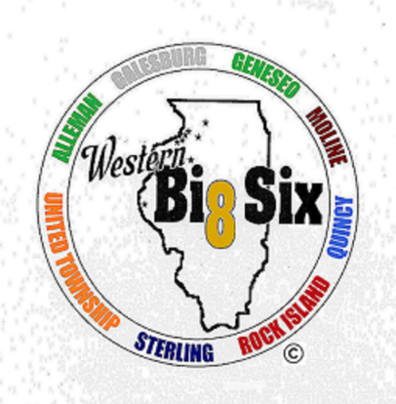
ALL CONFERENCE BOYS CROSS COUNTRY
First Team
John Hutton Moline Senior
Jackson McClellan Moline Senior
Justin Johnson Geneseo Junior
William Plumley Geneseo Senior
Galvin Allison Geneseo Sophomore
Fiker Rosen Quincy Junior
Ben Vasquez Galesburg Senior
Logan Veloz United Township Junior
Donovan Garro Rock Island Senior
Javon Bruce Sterling Senior

Second Team
Diego Portillo Alleman Senior
Jaeger Norton Moline Junior
Tyler Gehl Geneseo Sophomore
Ayden Triplett Quincy Junior
Sam Brown Sterling Senior
Cameron Taylor Sterling Junior
Thomas Holcomb Sterling Sophomore
Plamedi Nseka Galesburg Freshman
Hunter Toye Moline Freshman
Isaac Koster Geneseo Senior

ALL CONFERENCE GIRLS CROSS COUNTRY
First Team
Esther Brown Geneseo Senior
Jaide Flowers Geneseo Sophomore
Tess Hendrickson Alleman Freshman
Mattie Kindelsperger Alleman Junior
Avery Magerkurth Geneseo Junior
Alexandria Meyers Quincy Sophomore
Maddie Miller United Township Junior
Kylie Nicklaus Sterling Sophomore
Anna Schuering Quincy Junior
Olivia Schuering Quincy Freshman

Second Team
Caroline Adam Alleman Senior
Brianna Admire Galesburg Sophomore
Jossalyn Belvel Geneseo Sophomore
Abby DeBlieck Moline Junior
Lacey Laxton Geneseo Junior
Mackenzie Meirhaeghe Rock Island Sophomore
Rylee Noack Alleman Junior
Reese Terstriep Quincy Sophomore
Jade Schneider Quincy Senior
Anna Snyder Geneseo Junior

ALL CONFERENCE BOYS GOLF
First Team
Luke Lofgren Alleman Senior
Jason Runbom Galesburg Sophomore
Colton Sigel Rock Island Senior
Cole Nicholas Quincy Junior
Andre Marriott Alleman Freshman
Brady Walker Quincy Junior

Second Team
Aaron Rogers Moline Junior
Cameron Bergman Quincy Junior
Mason Steinert Geneseo Junior
Tommy Potter Moline Sophomore
Ben Templeton Galesburg Junior
Luke Chevalier Quincy Junior

ALL CONFERENCE GIRLS GOLF
First Team
Laci Novosel Quincy Junior
Saya Geisendorfer Quincy Sophomore
Paige Cain Quincy Junior
Kate Chevalier Quincy Senior
Maddie Pink Sterling Junior
Kacie Knary Moline Junior

Second Team
Keely Nguyen Geneseo Sophomore
Addie Mills Geneseo Freshman
Olivia Schwingle Sterling Senior
Paige Laingen Geneseo Senior
Dulaney Bennett Quincy Sophomore
Anya Nanjappa Quincy Junior

ALL CONFERENCE GIRLS SWIMMING
First Team
Ari Bailey Galesburg Senior
Celia Cervantes Moline Senior
Hanna Gault Moline Junior
Sophia Greko Moline Junior
Hailee Messerly Moline Freshman
Olivia Sholl Rock Island Junior
Miriam Trenary Moline Senior
Ciara Van Note Moline Junior
Annika Zemek Moline Junior

Second Team
Ava Dietz Rock Island Sophomore
Mackenzi Fulton United Township Junior
Bailey Hecker Rock Island Sophomore
Ella McKinley Rock Island Senior
Ava Navarro Moline Freshman
Kate Parker United Township Sophomore
Abbie Roos Rock Island Junior
Jillian Smith United Township Junior
Josie Smith United Township Freshman
Allyson Smithson Rock Island Senior

ALL CONFERENCE GIRLS TENNIS
First Team
Monika Birski Moline Senior
Reese Williams United Township Junior
Lauren Myers Moline Senior
Sarah Gustafson Moline Junior
Lucy Rector Alleman Senior
Kate Rector Alleman Sophomore

Second Team
Matti Brower Moline Senior
Zayda Graham Moline Freshman
Emma Dunker Geneseo Senior
Emma Claeys Geneseo Senior
Camile Keys Moline Junior
Lily Hayes Quincy Freshman

